**Activity_main.xml:**

*<?*xml version="1.0" encoding="utf-8"*?>*<RelativeLayout xmlns:android="http://schemas.android.com/apk/res/android"  
  
 xmlns:tools="http://schemas.android.com/tools"  
 android:layout_width="match_parent"  
 android:layout_height="match_parent"  
 tools:context=".MainActivity">  
  
 <LinearLayout  
 android:layout_width="match_parent"  
 android:layout_height="match_parent"  
 android:weightSum="10"  
 android:orientation="vertical">  
  
 <TextView  
 android:id="@+id/title_text_view"  
 android:layout_width="match_parent"  
 android:layout_height="wrap_content"  
 android:text="Ask"  
 android:textSize="40dp"  
 android:textAppearance="?android:textAppearanceLarge"  
 android:textStyle="bold"  
 android:textAlignment="center"/>  
  
 <TextView  
 android:layout_width="match_parent"  
 android:layout_height="wrap_content"  
 android:layout_weight="2"/>  
  
 <Button  
 android:id="@+id/btnAsk"  
 android:layout_width="wrap_content"  
 android:layout_height="wrap_content"  
 android:textAlignment="center"  
 android:layout_gravity="center"  
 android:textSize="20dp"  
 android:onClick="movepage"  
 android:text="Ask" />  
  
 <TextView  
 android:layout_width="match_parent"  
 android:layout_height="wrap_content"  
 android:layout_weight="0.5"  
 android:text="User has ignored the Question!"  
 android:textAlignment="center"  
 android:textSize="20dp"/>  
  
 </LinearLayout>  
</RelativeLayout>

**MainActivity.java:**

package com.example.lab 7;  
  
import android.content.Intent;  
import android.support.v7.app.AppCompatActivity;  
import android.os.Bundle;  
import android.view.View;  
import android.widget.Button;  
  
public class MainActivity extends AppCompatActivity {  
  
 Button btn;  
  
 @Override  
 protected void onCreate(Bundle savedInstanceState) {  
 super.onCreate(savedInstanceState);  
 setContentView(R.layout.*activity_main*);  
  
 btn= findViewById(R.id.*btnAsk*);  
  
 }  
  
 public void movepage(View v)  
 {  
 Intent in = new Intent(MainActivity.this,Ask.class);  
 startActivity(in);  
 }  
}

**Activity_ask.xml:**

*<?*xml version="1.0" encoding="utf-8"*?>*<RelativeLayout xmlns:android="http://schemas.android.com/apk/res/android"  
  
 xmlns:tools="http://schemas.android.com/tools"  
 android:layout_width="match_parent"  
 android:layout_height="match_parent"  
 tools:context=".MainActivity">  
  
 <LinearLayout  
 android:layout_width="match_parent"  
 android:layout_height="match_parent"  
 android:weightSum="10"  
 android:orientation="vertical">  
  
  
  
 <TextView  
 android:id="@+id/title_text_view"  
 android:layout_width="match_parent"  
 android:layout_height="wrap_content"  
 android:text="Ask"  
 android:textSize="40dp"  
 android:textAppearance="?android:textAppearanceLarge"  
 android:textStyle="bold"  
 android:textAlignment="center"/>  
  
 <TextView  
 android:layout_width="match_parent"  
 android:layout_height="wrap_content"  
 android:layout_weight="2"  
 android:id="@+id/textResult"  
 android:textSize="40dp"  
 android:textAppearance="?android:textAppearanceLarge"  
 android:textStyle="bold"  
 android:textAlignment="center"/>  
  
  
 <TextView  
 android:layout_width="match_parent"  
 android:layout_height="wrap_content"  
 android:layout_weight="0.5"  
 android:text="Do you want to save your name?"  
 android:textAlignment="center"  
 android:textSize="20dp"/>  
  
 <EditText  
 android:layout_width="match_parent"  
 android:layout_height="wrap_content"  
 android:layout_weight="0.5"  
 android:id="@+id/textInput"  
 android:hint="Enter your Name"/>  
  
 <LinearLayout  
 android:layout_width="match_parent"  
 android:layout_height="wrap_content"  
 android:orientation="horizontal"  
 android:weightSum="3"  
 android:layout_weight="0.5">  
 <Button  
 android:id="@+id/btnYes"  
 android:layout_width="wrap_content"  
 android:layout_height="wrap_content"  
 android:textAlignment="center"  
 android:layout_gravity="center"  
 android:textSize="20dp"  
 android:text="Yes"  
 android:onClick="optionYes"  
 android:layout_weight="1"  
 android:textAllCaps="false"/>  
 <Button  
 android:id="@+id/btnNo"  
 android:layout_width="wrap_content"  
 android:layout_height="wrap_content"  
 android:textAlignment="center"  
 android:layout_gravity="center"  
 android:textSize="20dp"  
 android:text="No"  
 android:onClick="optionNo"  
 android:layout_weight="1"  
 android:textAllCaps="false"/>  
 <Button  
 android:id="@+id/btnCancel"  
 android:layout_width="wrap_content"  
 android:layout_height="wrap_content"  
 android:textAlignment="center"  
 android:layout_gravity="center"  
 android:textSize="20dp"  
 android:text="Cancel"  
 android:onClick="optionCancel"  
 android:layout_weight="1"  
 android:textAllCaps="false"/>  
 </LinearLayout>  
  
 </LinearLayout>  
  
</RelativeLayout>

**Ask.java:**

package com.example.lab 7;  
  
import android.content.Intent;  
import android.support.v7.app.AppCompatActivity;  
import android.os.Bundle;  
import android.view.View;  
import android.widget.Button;  
import android.widget.EditText;  
import android.widget.TextView;  
import android.widget.Toast;  
  
public class Ask extends AppCompatActivity {  
  
 Button btnYes,btnNo,btnCancel;  
 EditText input;  
 TextView output;  
 String data;  
  
 @Override  
 protected void onCreate(Bundle savedInstanceState) {  
 super.onCreate(savedInstanceState);  
 setContentView(R.layout.*activity_ask*);  
  
  
 btnYes = (Button)findViewById(R.id.*btnYes*);  
 btnNo = (Button)findViewById(R.id.*btnNo*);  
 btnCancel = (Button)findViewById(R.id.*btnCancel*);  
 output = (TextView)findViewById(R.id.*textResult*);  
 input = (EditText) findViewById(R.id.*textInput*);  
  
 }  
  
 public void optionYes(View v)  
 {  
 data = input.getText().toString();  
 output.setText(data);  
 Toast.*makeText*(getBaseContext(),"Name saved.",Toast.*LENGTH_SHORT*).show();  
 }  
 public void optionNo(View v)  
 {  
 output.setText("");  
 Toast.*makeText*(getBaseContext(),"Name not saved.",Toast.*LENGTH_SHORT*).show();  
 }  
  
 public void optionCancel(View v)  
 {  
 Intent in = new Intent(Ask.this,MainActivity.class);  
 startActivity(in);  
 }  
}

**Output:**

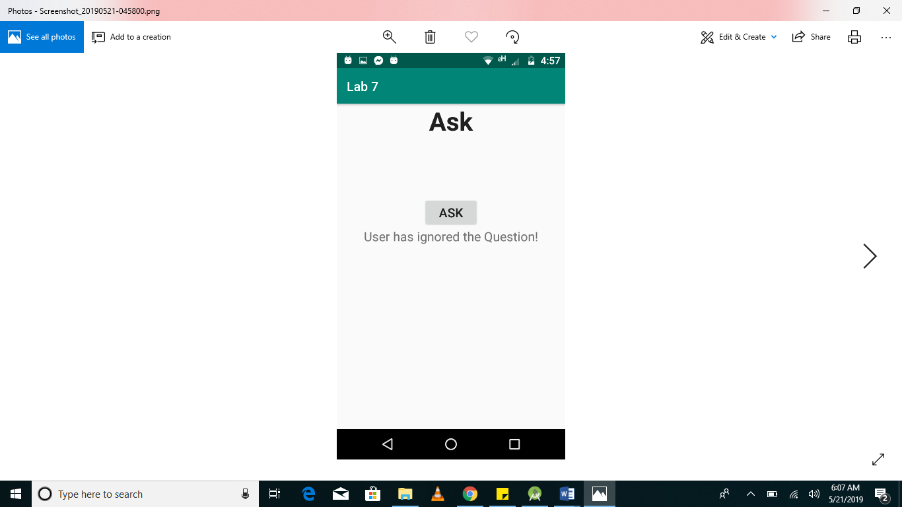

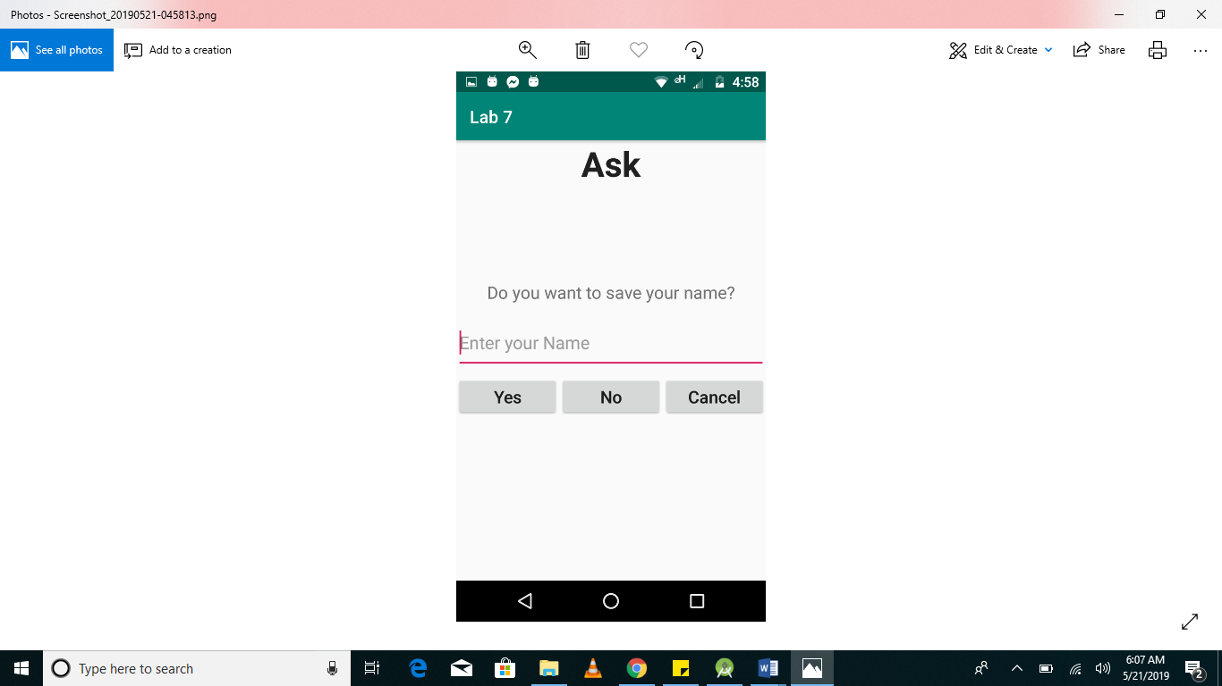

**Task 02:**

**Activity_main.xml:**

*<?*xml version="1.0" encoding="utf-8"*?>*<RelativeLayout xmlns:android="http://schemas.android.com/apk/res/android"  
  
 xmlns:tools="http://schemas.android.com/tools"  
 android:layout_width="match_parent"  
 android:layout_height="match_parent"  
 tools:context=".MainActivity">  
  
 <LinearLayout  
 android:layout_width="match_parent"  
 android:layout_height="match_parent"  
 android:weightSum="10"  
 android:orientation="vertical">  
  
  
  
 <TextView  
 android:id="@+id/title_text_view"  
 android:layout_width="match_parent"  
 android:layout_height="wrap_content"  
 android:text="Clock"  
 android:textSize="40dp"  
 android:textAppearance="?android:textAppearanceLarge"  
 android:textStyle="bold"  
 android:textAlignment="center"/>  
  
 <TextView  
 android:layout_width="match_parent"  
 android:layout_height="wrap_content"  
 android:layout_weight="1"/>  
  
 <TextClock  
 android:layout_width="match_parent"  
 android:layout_height="wrap_content"  
 android:textSize="40dp"  
 android:layout_weight="1"  
 android:id="@+id/clock_time"  
 android:gravity="center"  
 />  
  
  
 <RadioGroup  
 android:layout_width="match_parent"  
 android:layout_height="wrap_content">  
  
 <RadioButton  
 android:layout_width="match_parent"  
 android:layout_height="wrap_content"  
 android:text="Hours"  
 android:id="@+id/radio_hh"  
 android:textSize="20dp"/>  
 <RadioButton  
 android:layout_width="match_parent"  
 android:layout_height="wrap_content"  
 android:text="Minutes"  
 android:id="@+id/radio_mm"  
 android:textSize="20dp"/>  
 <RadioButton  
 android:layout_width="match_parent"  
 android:layout_height="wrap_content"  
 android:text="Seconds"  
 android:id="@+id/radio_ss"  
 android:textSize="20dp"/>  
  
 </RadioGroup>  
  
 <Button  
 android:id="@+id/btnUpdate"  
 android:layout_width="wrap_content"  
 android:layout_height="wrap_content"  
 android:textAlignment="center"  
 android:layout_gravity="center"  
 android:textSize="20dp"  
 android:onClick="onClick"  
 android:text="Update" />  
  
   
  
  
 </LinearLayout>  
  
</RelativeLayout>

**MainActivity.java:**

package com.example.lab 7  
  
import android.content.Intent;  
import android.support.v7.app.AppCompatActivity;  
import android.os.Bundle;  
import android.view.View;  
import android.widget.Button;  
import android.widget.RadioButton;  
import android.widget.RadioGroup;  
import android.widget.TextClock;  
import android.widget.Toast;  
  
public class MainActivity extends AppCompatActivity{  
  
 RadioButton hradio,mradio,sradio, radioButton;  
 Button update;  
 TextClock time;  
 RadioGroup radioGroup;  
  
  
 @Override  
 protected void onCreate(Bundle savedInstanceState) {  
 super.onCreate(savedInstanceState);  
 setContentView(R.layout.*activity_main*);  
  
  
 hradio = findViewById(R.id.*radio_hh*);  
 mradio = findViewById(R.id.*radio_mm*);  
 sradio = findViewById(R.id.*radio_ss*);  
 time = findViewById(R.id.*clock_time*);  
 update = findViewById(R.id.*btnUpdate*);  
  
  
  
 time.setFormat12Hour("kk:mm:ss");  
  
 if(hradio.isChecked()){  
 mradio.setChecked(false);  
 sradio.setChecked(false);  
 }  
 else if(mradio.isChecked()){  
 hradio.setChecked(false);  
 sradio.setChecked(false);  
 }  
 else if(sradio.isChecked()){  
 hradio.setChecked(false);  
 mradio.setChecked(false);  
 }  
  
 update.setOnClickListener(new View.OnClickListener() {  
 @Override  
 public void onClick(View v) {  
  
 if(hradio.isChecked()){  
 Intent in = new Intent(MainActivity.this, Update.class);  
 String hstring = hradio.getText().toString();  
 String mstring = mradio.getText().toString();  
 String sstring = sradio.getText().toString();  
 clock ctime = new clock(hstring,mstring,sstring);  
 in.putExtra("object", ctime);  
 startActivity(in);  
 }  
  
 else if(mradio.isChecked()){  
 Intent in = new Intent(MainActivity.this, Update1.class);  
 String hstring = hradio.getText().toString();  
 String mstring = mradio.getText().toString();  
 String sstring = sradio.getText().toString();  
 clock ctime = new clock(hstring,mstring,sstring);  
 in.putExtra("object", ctime);  
 startActivity(in);  
 }  
  
 else if(sradio.isChecked()){  
 Intent in = new Intent(MainActivity.this, Update2.class);  
 String hstring = hradio.getText().toString();  
 String mstring = mradio.getText().toString();  
 String sstring = sradio.getText().toString();  
 clock ctime = new clock(hstring,mstring,sstring);  
 in.putExtra("object", ctime);  
 startActivity(in);  
 }  
  
 else {  
 Toast.*makeText*(getBaseContext(),"No option selected",Toast.*LENGTH_SHORT*).show();  
 }  
  
 }  
 });  
   
  
}

**Output:**

